Sprint #3 Report

**Stop Doing:**

* Scrum board and burn-up chart failure
* Did not break several user stories into tasks
* Git conflict and merge issues

**Start Doing:**

* Take more time in initial scrum meeting
* Do planning poker to estimate story points
* Game testing / play testing
* Change scrum board from Trello to offline physical whiteboard

**Continue Doing:**

* Have almost daily in-person meetings
* Have a good abstract plan (good user stories)

**Work Completed:**

This is a list of the user stories that were completed during the sprint:

* (3) As a player, I want there to be a Boss Monster Sprite so that when I’m fighting a boss monster, I know what kind of challenge I’m facing, and I can feel good when I overcome it.
* (3) As a designer, I want there to be a Monster Tracker object in the game that keeps track of what enemies the player has killed so that I can set up systems that respond to player action incentivizing theme to shift strategies.
* (8) As a game designer, I want the number of followers that the player can take with them when they retreat to a new world to be limited so that they have to make decisions about who to take with them and if they will hire more miners/teleporters in the next world.

**Work Not Completed:**

This is a list of the user stories that were NOT completed during the sprint:

* (5) As a player, I want the game’s look to be consistent and professional so that I maintain awareness of the game state without being distracted.
* (8) As a designer, I want the statistics of the monsters, fighters, and followers to be balanced so that players can expect a certain runtime.
* (8) As a designer, I want the technologies to modify the other statistics in a game in such a way that provides the player with meaningful choices that each feel like they have an impact so that the player is entertained and keeps playing.
* (5) As a designer, I want there to be a way of scoring a player’s run-through the game so that they can know their competency and perhaps set goals for future attempts.

**Work Completion Rate:**

* We have completed a total of 3 user stories.
* We have spent around 24. We have spent around 2 days per user story. With about 4 ideal work hours spent each day. The problem that came up was we didn't get to finishing the stories.

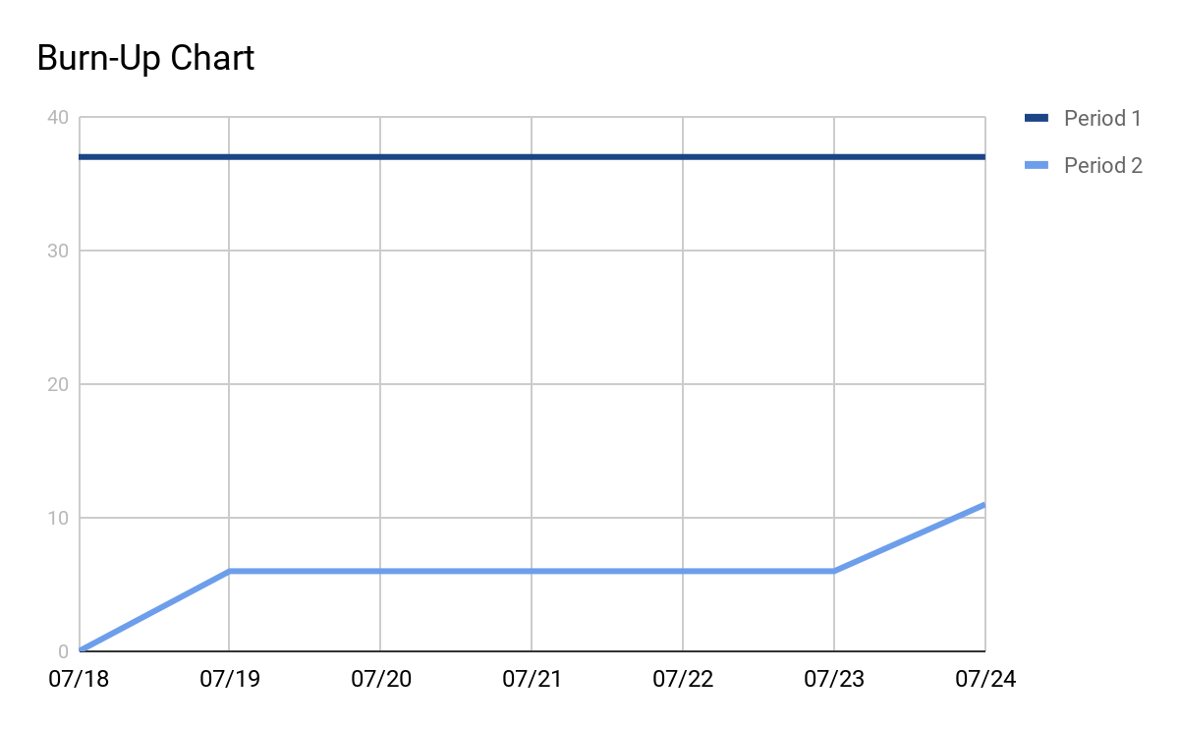

**\***We have used user story points instead of time for each task because we did not break up many of the user stories and forgot to give lots of tasks times.